New synthesis route and crystal structure of philosophers' stone.

First Author^{a,*}, Second Contributor^{b}, Third Supervisorª

ª Abteilung für Kristallographie und Kunst, Universität des Flachlandes, Dorfstrasse 1, 5000 Aarau.
^{b} Faculty of Applied Alchemy, Nicolas-Flamel Institute of Pure Science, Paracelsusplatz, 8840 Einsiedeln.

E-mail: first.author@uni-flachland.ch

The text of your abstract should ideally not exceed half page of text in this template when formatted in Arial 12 pt. Together with optional figures, references, tables etc., the abstract may not be longer than 1 page. Please use Arial 14 pt, bold for title, Arial 12 pt. for main text, authors, affiliations, references and annotations, and Arial 12 pt. italic for figure and table captions. The abstract should be submitted as a word document by e-mail to secretariesdivt@csem.ch with a deadline on 01. July 2015. When submitting the abstract, please be sure to specify “SGK/SSCr Annual Meeting – Abstract” in the subject field, and adding your name will also be useful.
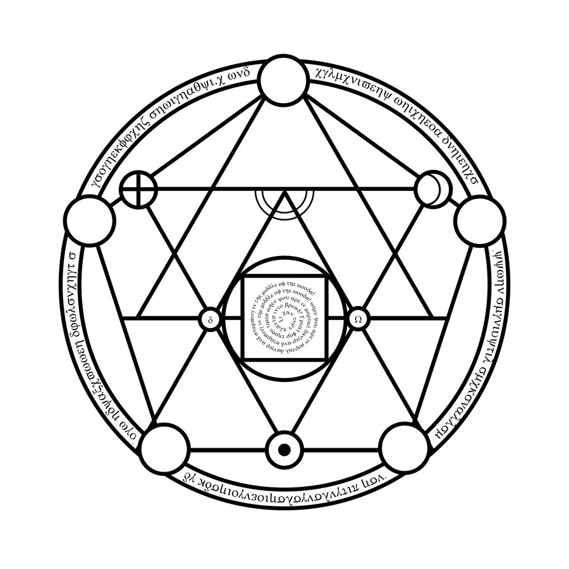
Figure 1. Schematic representation of our new synthesis route.
Table 1. Crystal structure parameters of the newly synthesized mineral. Sp. gr. Au1/1Hg (Nr. 231).
Element | Site | Mixing order
Purified gold | 2a (0,0,0) | 1
Sophic mercury | 4c (x,2x,1/4) | 2
In the end, please don’t forget to rename the file with your abstract by including your last name into the filename, and just submit it². Looking forward to meeting you all in Neuchâtel on 14. Sept. 2015.

Alchem. Adv. Rev. Lett., 56, 020304 (1545).
The e-mail for submission is also given at the meeting website: indico.psi.ch/event/SGK-SSCR-Annual-Meeting-2015

