Title of Abstract (Arial, 12 pt, centered, bold)

Presenting Author*, Second Author¹, Third Author², Other Authors^{1,2,3} (Arial, 12 pt, centered)

*(email presenting author)

¹ First affiliation, Country (Arial, 10 pt, centered, italic)
²Second affiliation, Country (Arial, 10 pt, centered, italic)
³Additional affiliation, Country (Arial, 10 pt, centered, italic)

Abstract body text in Arial, 10 pt, single space. Maximum 1 page without changing page margins or line spacing. Accepted file formats "doc", "docx".
Figures may be provided, but it is not mandatory. Select text wrapping for figures as "top and bottom". Group subfigures in external software and paste as single figure file. Label subfigures a), b), c) and provide caption explaining each subfigure.
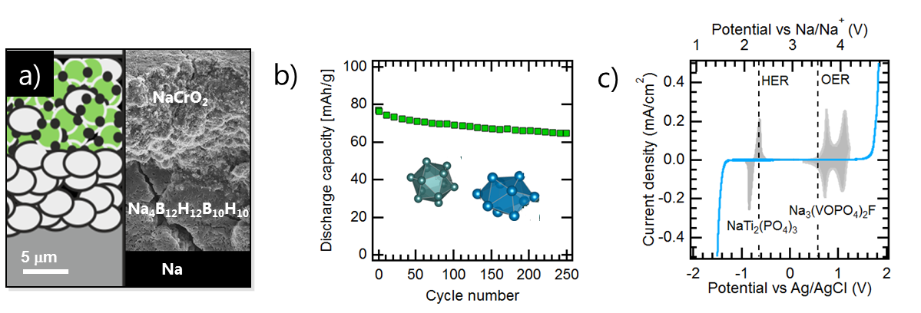

Figure 1: a) explanation for first subfigure, b) explanation for second subfigure, etc. (Arial, 10 pt)

More abstract body text in Arial, 10 pt, single space. References such as Ref. 1 should be provided according to the ACS style guide.² List all authors and do not use "et al." or similar abbreviations

We are looking forward to welcoming you to the virtual BeLi 26!

References:

¹ K. Mizushima, P.C. Jones, P.J. Wiseman, J.B. Goodenough, Mater. Res. Bull. 1980, 15, 783-789
² A. M. Coghill, L. R. Garson, The ACS Style Guide, DOI: 10.1021/bk-2006-STYG

Do not exceed one page!

