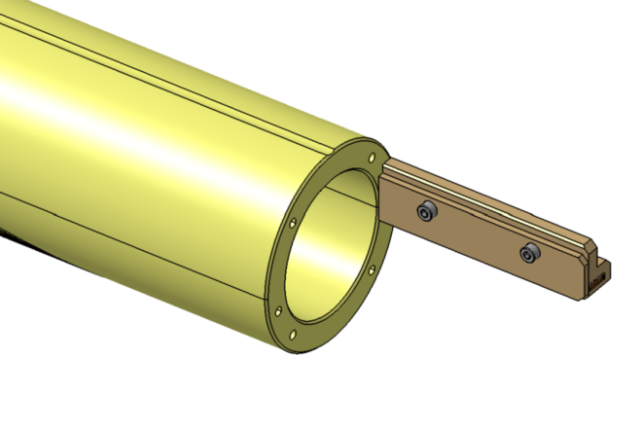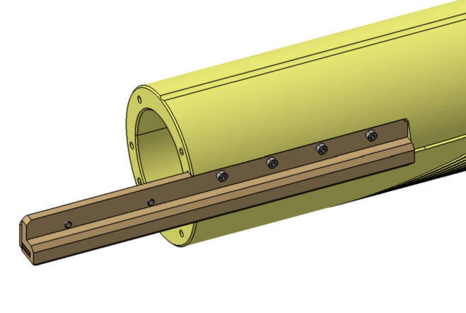
Figure 1. Coil end with protective cap.

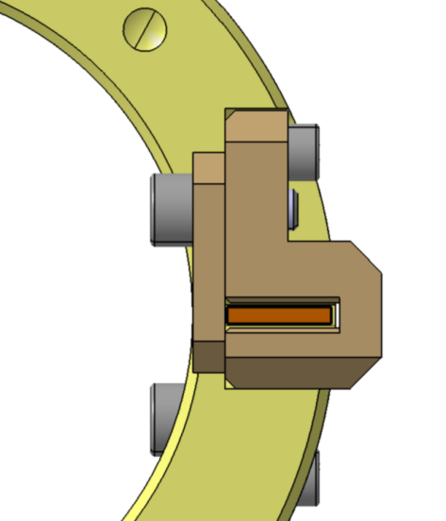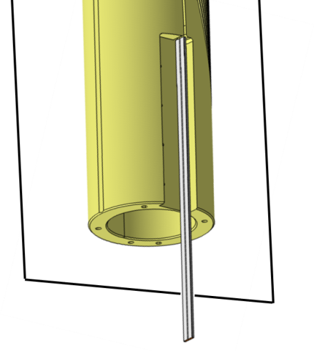
Working bench plane

Figure 2. Coil end positiong for cap removal (left) and exposed cable after cap removal (right).

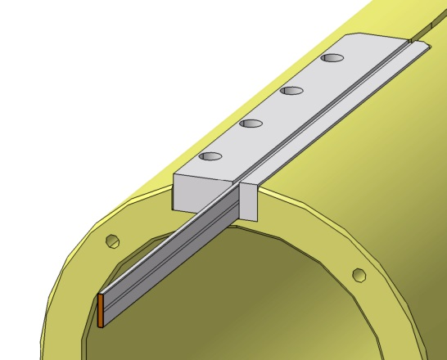
Figure 3.Cable locked by the support block pieces.

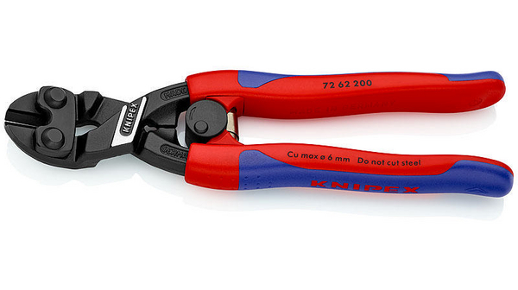

Figure 4.Flat cutter (left) and exaple of cut result (right).

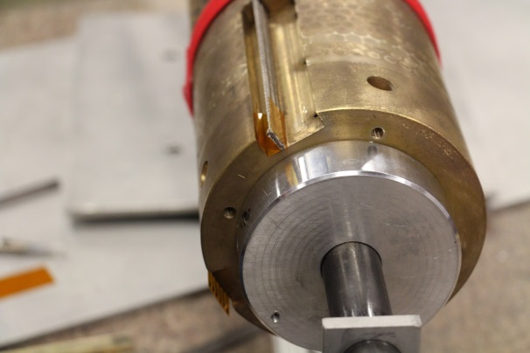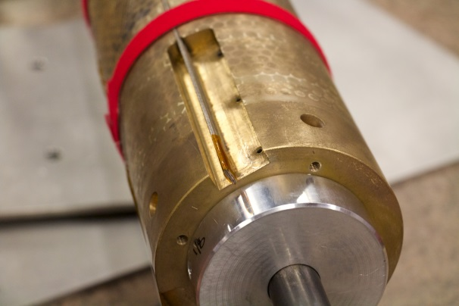
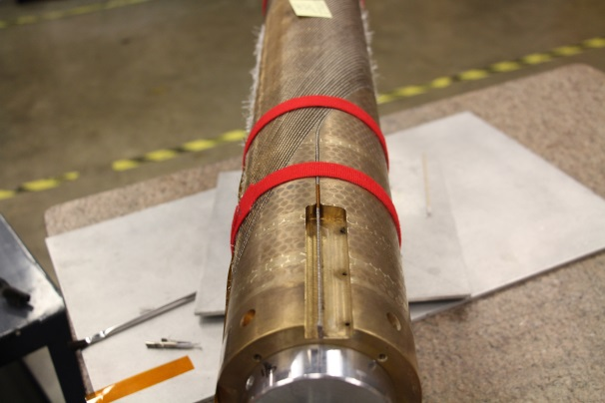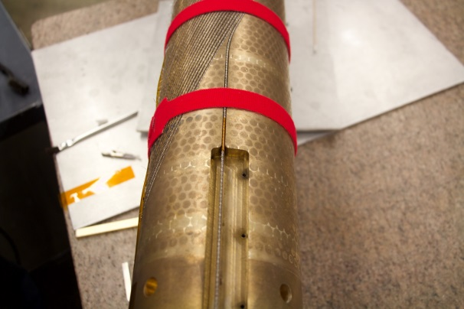
Figure 5. From top left clockwise, Kapton slice, the slice wrapped on the cable, and the slice inside the channel.

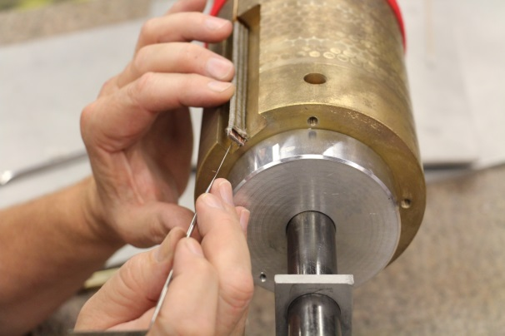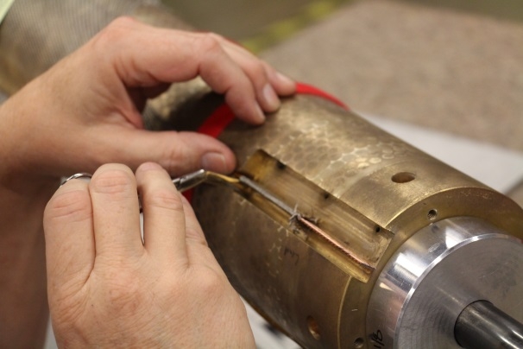
Figure 6.loosening of the fiber glass sleeve insulation (left) and starting of sleeve cut with bended scissors.

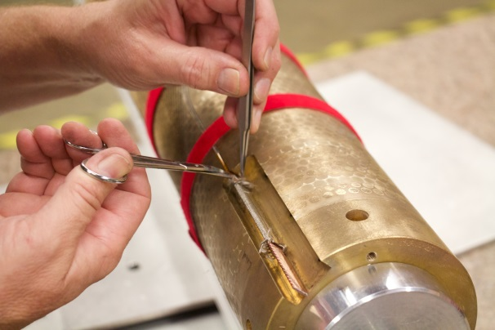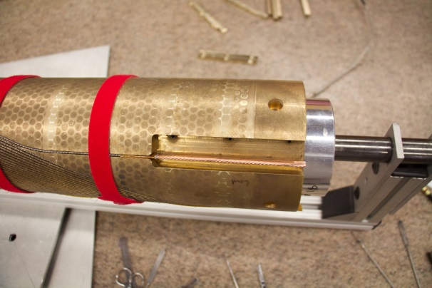
Figure 7. Cutting away the insulation (left) and the bare cable (right).

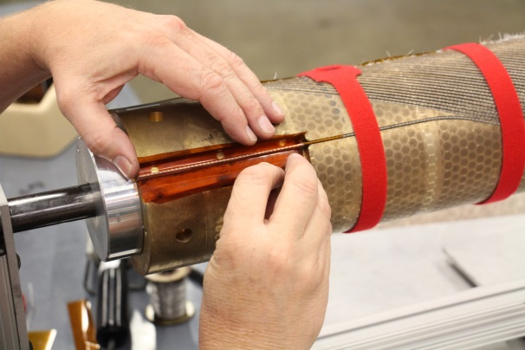
Figure 8. Kapton foil to set a thermal barrier during tinning

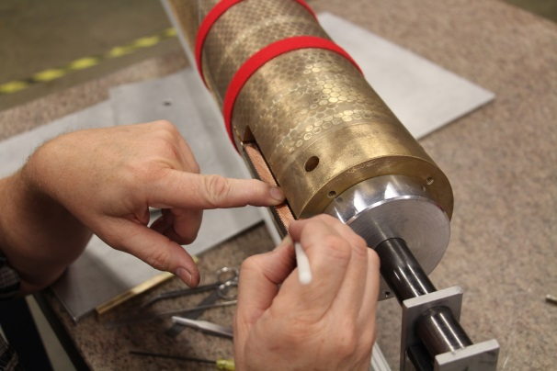
Figure 9. Cleaning of the cable face to be tinned.

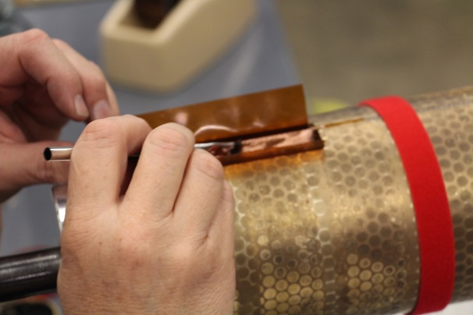
Figure 10. Apply the soldering flux on the exposed cable face.

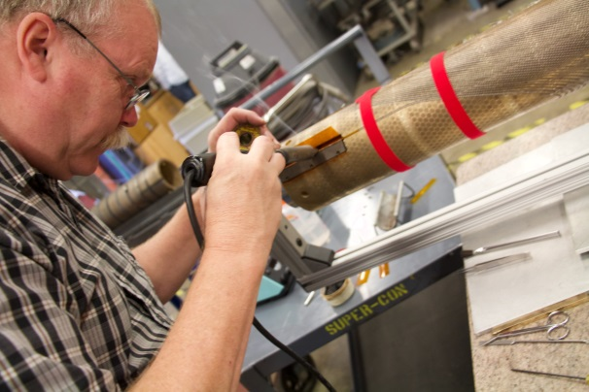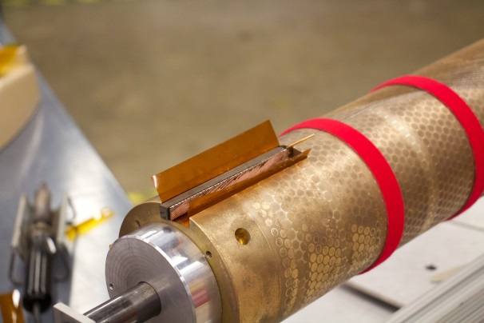
Figure 11. Application of the solder on the cable (left) and final results (right).

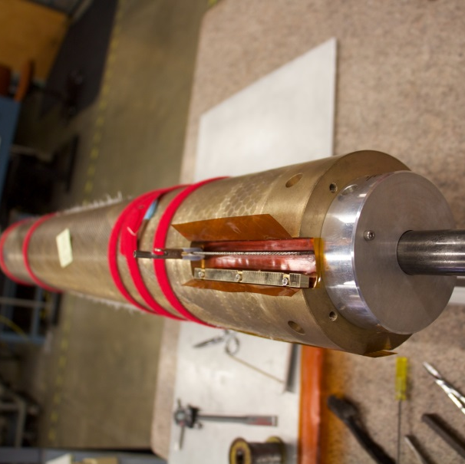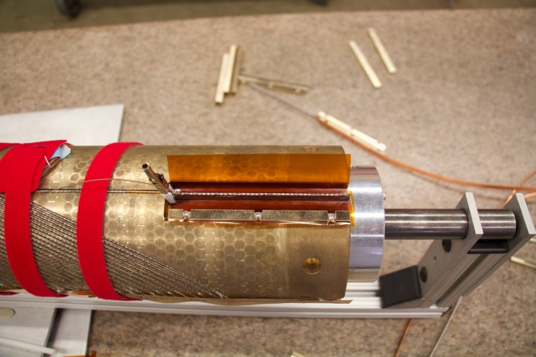
Figure 13. Protection of the voltage tap for the splicing operation.

Figure 14. End of the cable with edge broken.

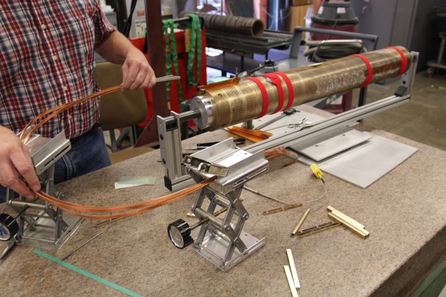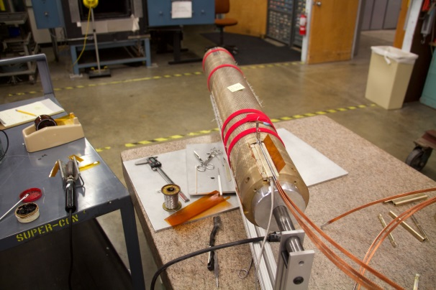
Figure 15. Anchor the NbTi leads to a stable support (left) and then line the cable ends into the splice box (righ).

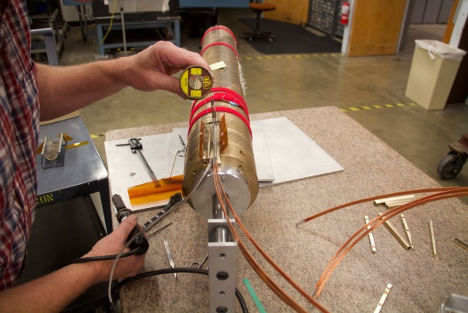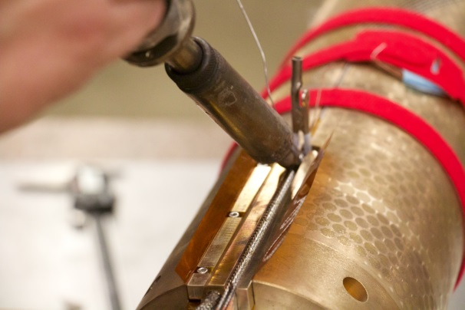
Figure 16. Splicing operation: checking if the splice reached the melting temperature of the solder (left) and applying the solder all along the top splice (right).

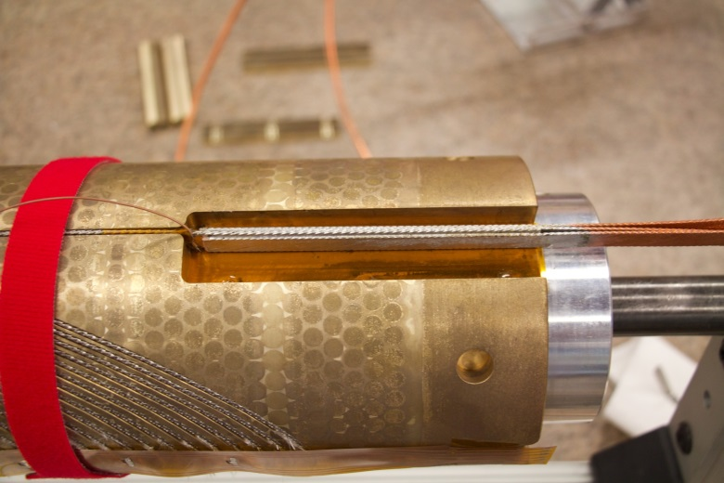
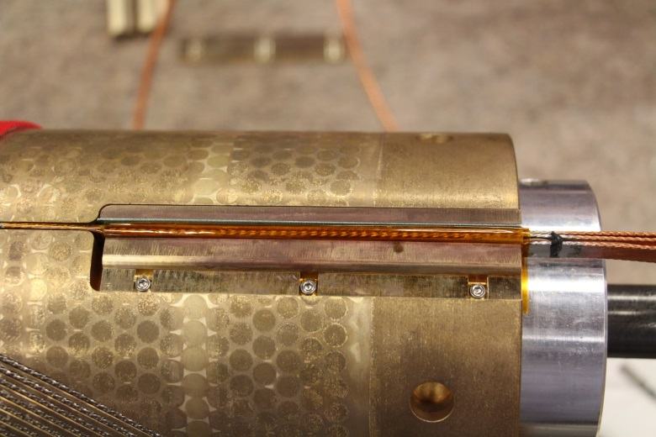
Vtap wire
Figure 17. The final sandwich of the splice with the Kapton protective layer (top) and the cable splice wrapped with Kapton (bottom). Detail of the Kapton cables wrap is shown at the bottom right part of the figure.
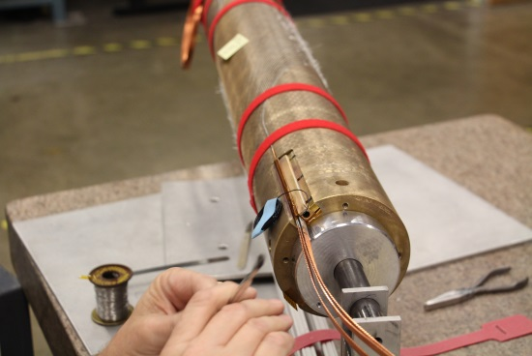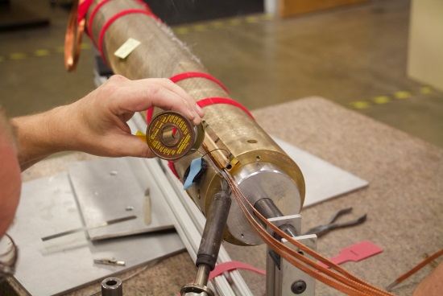
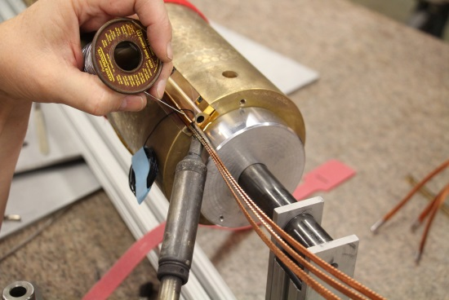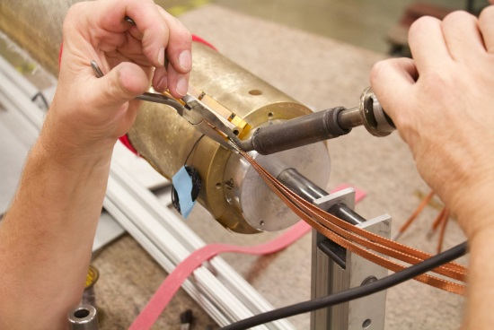
∆L
Figure 18. Soldering process of the Nb-Ti current leads in order to achieve vacuum tightness during vacuum impregnation.

