Abstracts for Facility retreats
M. Author,^{1,*} S. Author,² and O. Author¹
¹Lab for This and That (LST), PSI
²University of Oz, Emerald City, Land of Oz

Efficient collaboration between scientific groups within large organisations is a standing question in national laboratories [1]. An organised yearly meeting of topic-related groups in form of a retreat has been lately a prominent approach to face this issue. The project presented here aims at efficient communication in preparation of such retreat by providing guidelines. Those cover the context and most important aspects of the individual projects, their status and results, potential collaboration, as well as future perspectives. A solution consisting of content and structure guidelines for submitted abstracts is implemented in the call for participation in a retreat performed at the Paul Scherrer Institute (see Figure). An evaluation of the usability and effect of this measure requires feedback by the participants about the feasibility to implement those guidelines as well as to what extent they might have helped the communication at the retreat. With such feedback this example might help to improve communication for future retreats.

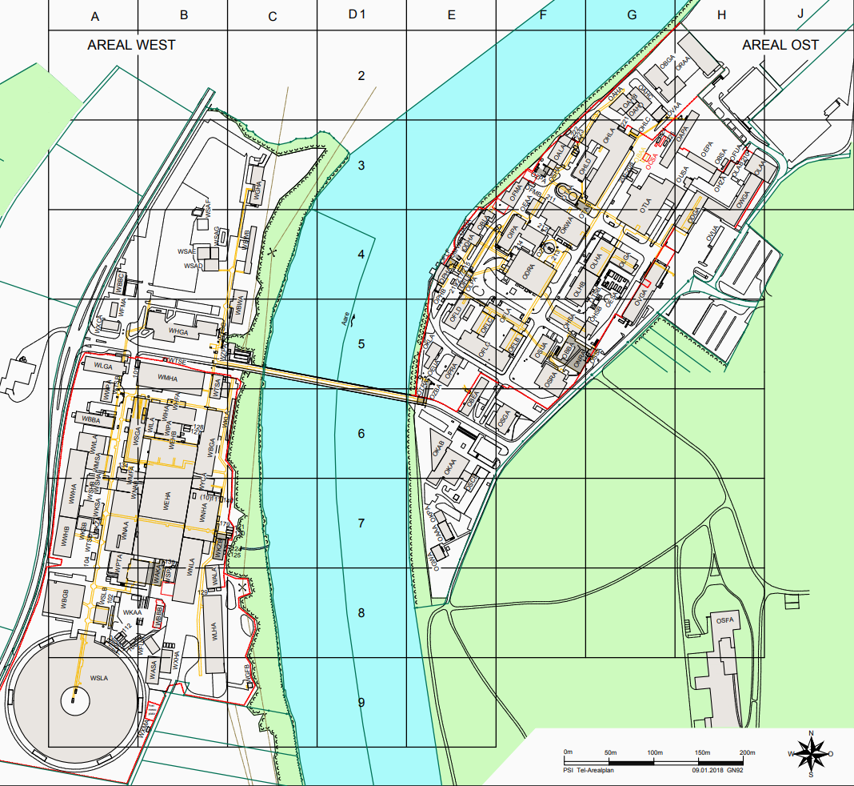
FIG. 1: The map of PSI (German: Arealplan).

[1] Pearson, PR, Lovely, B, et al. ; Strategy PR meeting XZY123. The Lab 12, 1-2 (1942); https://doi.org/10.1234/theyforgot.this.contribution

